**Southeast University**

Department Of Computer Science & Engineering



**Course Code : CSE384**

**Course Name : Database Design**

**Project Name : Inventory Management System**

**Date : 27-08-2022**

**Submitted By**

**Most. Laila Akter**

**2019000010096**

**Submitted To**

**Mr. Nahin Kumar Dey**

**Lecturer, Southeast University**

**Project Overview:**

Inventory management is the process of ordering, storing, using, and selling a company's inventory. This includes the management of raw materials, components, finished products, warehousing and processing of such items. In manufacturing enterprises, managing inventory is a difficult task. Many challenges arise in supply chains. So, Inventory management system needs a database to store these data on these products, details & customers.

This inventory management system will help to track the correct inventory in short time and it will be easier to manage and sort out the inventory as well. These will help to manage the products, order rate and employees.

The system will also have customer & supplier. Customers can choose what products they will be placing order from the inventory and supplier will be able to provide stocks.

Inventory management system has seven entities. They are:

|  |  |
| --- | --- |
| DB Table | Description |
| Brand/inventory | This has details of inventory id, product id, quantity and its updated time. |
| Products | It has details of product id, slugs, name, price, vat and references. |
| Item | Details of a specific item name, id ,update date etc |
| order | It has information on order id, product id, arrival time, order time, deadline etc. |
| User | This is user information on his id, name, phone, address and DOB. |
| Order_items | It has details of customer id, order time and ordered time |
| Product_meta | This has product id, order id, ordering time, price & vat. |

**Functionality:**

Database allows admins to do:

1. Enter customer information and place their orders. Each product has its own order details.
2. Enter user services by supplying the products. Each products has its own product meta.
3. Enter products information and place the products by their suitable inventory

Some procedure & function for the database are:

1. Trigger (Price): Products should be price included.
2. Trigger (Vat): Product should be vat included.
3. Function (slug): to identify products within short time

**Targeted Audience:**

This database is meant to be used by the companies which have shown multiple problems arranging their system, sorting out the products, getting orders from the users and problem stocks. So, if they integrate this database, they solve their storing problems. Many big industries like Food, Cloth, hardware etc. face multiple inventory issues. So, it can be effective for them

**Future Of Database:**

The database is made using mysql. We can use the database to manage any inventory system like Food warehousing, Cosmetics storing, Raw products storing and many more. Followings are the goal that needs to be done in future:  
1. Add transaction system.

2. Add specified suppliers’ details.

3. Find out more efficient data on inventory.

4. Adding payment gateway.

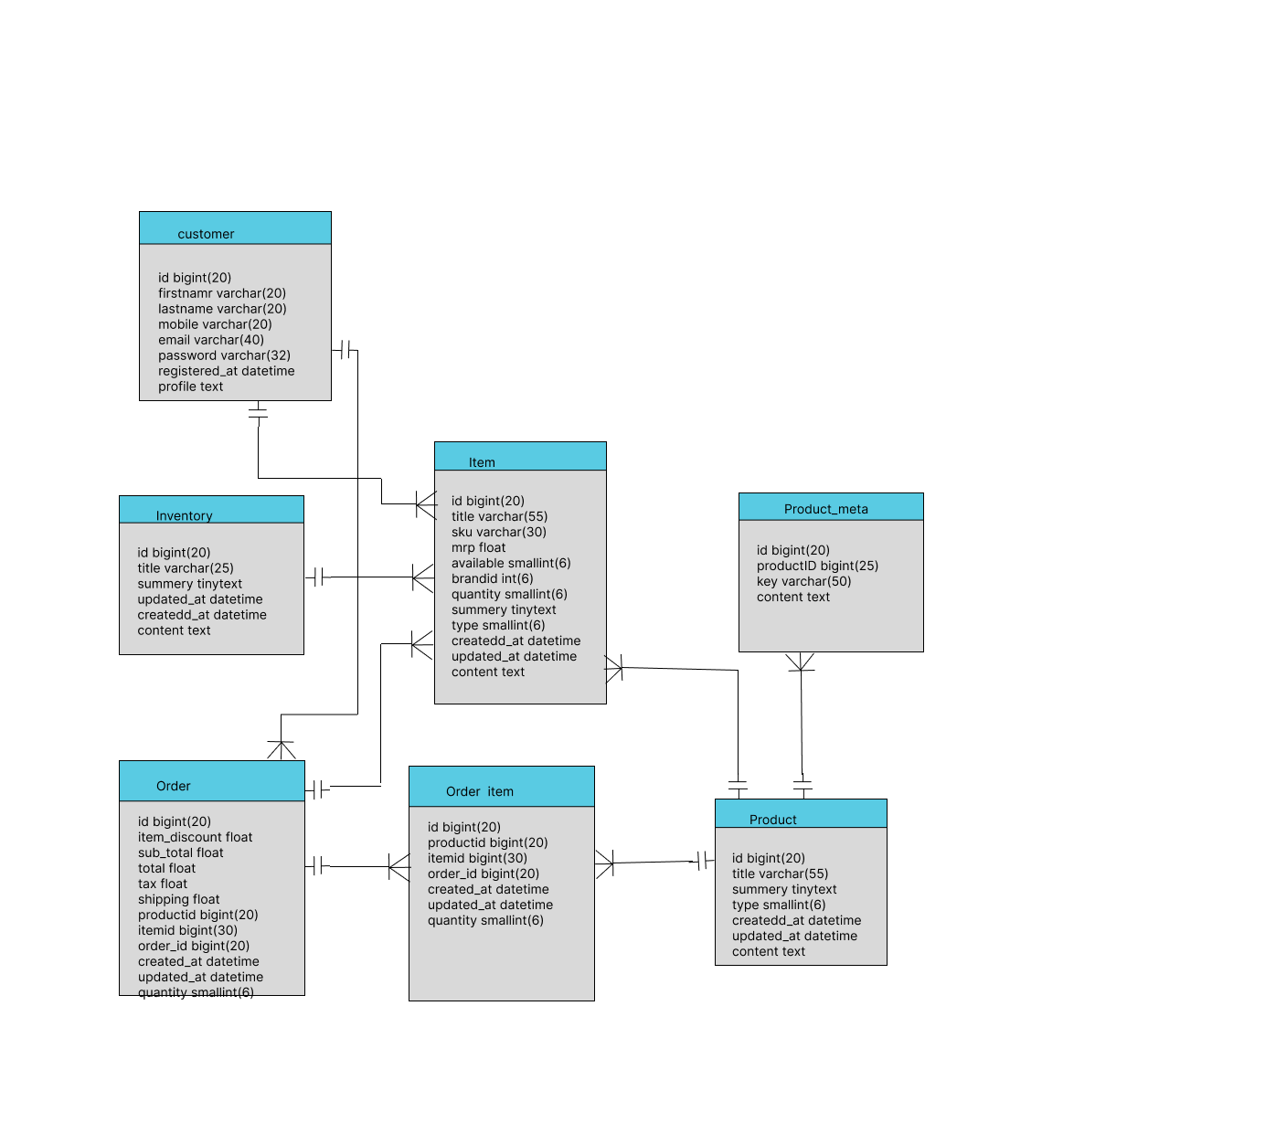

Fig: Schema Diagram Of Inventory Management System

**Schema Diagram**